Fine-Tuning Transformer Models for NLP Tasks
(News Classification)

Team Members
- Mohammed Mossad Ibrahim Qassem
- Mohammed Ibrahim Mohammed Desoky
- Muhammed Alaa Ali
- Marwa Emad AbdelFattah
- Shahd Essam Youssef
- Shahd Mohamed Elaraby
- Gehad Mohammed Abbas

Supervised By:
Eng. Maryam Mahmoud

- Introduction
This project focuses on classifying news articles into four categories: World, Sports, Business, and Sci/Tech. We used a dataset called AG News, which contains a large number of news articles, and fine-tuned a pre-trained model called DistilBERT to perform this classification task. The goal was to teach the model how to read the title and description of a news article and predict which category it belongs to with high accuracy
- Problem Statement

The task is to classify news articles based on their content. The AG News dataset has 120,000 articles for training and 7,600 for testing. Each article comes with a category label (originally numbered 1 to 4, which we adjusted to 0 to 3), a title, and a description. The challenge was to handle messy text—like extra symbols or punctuation—and ensure the model could understand and classify the articles correctly. We also needed a model that could handle this task efficiently without requiring too much computing power

- Dataset Details
- Source: The data comes from a Kaggle dataset, split into two files: train.csv (120,000 articles) and test.csv (7,600 articles).
- Structure: Each article has three parts: a category label (Class Index), a Title, and a Description.
- Steps We Took to Prepare the Data (Preprocessing):
  - We adjusted the category labels from 1-4 to 0-3 because the model expects labels to start from 0.
  - We combined the Title and Description into a single piece of text for each article to give the model more context.
  - We cleaned the text by removing punctuation, extra spaces, and converted everything to lowercase to make it consistent.
  - We converted the training and testing Pandas DataFrames into Hugging Face Dataset objects. This allows us to easily apply tokenization and formatting using the Hugging Face datasets library.
  - We used the pre-trained distilbert-base-uncased tokenizer to convert each article into a sequence of numerical tokens with a maximum length of 512.
  - Finally, we renamed the label column (Class Index) to labels, as required by the Hugging Face Trainer API.
- Why We Chose DistilBERT
We selected DistilBERT—a lighter version of BERT with 66 million parameters compared to BERT’s 110 million—because it is approximately 60% faster while retaining 97% of BERT’s accuracy. This made it ideal for working within Kaggle’s limited computational resources. It is also easy to fine-tune using Hugging Face’s tools, offering a strong balance between speed and performance. We considered other models like RoBERTa, which was more accurate but slower and resource-intensive, and GPT, which is optimized for text generation rather than classification—making them less suitable for our task.

- How We Trained the Model
- Setting Up the Model: We loaded the DistilBERT model, specifically the distilbert-base-uncased version, and told it we have 4 categories to predict.
- Training Settings:
- Training Arguments:
We used a learning rate of 5e-5, trained the model for up to 10 epochs, and set the batch size to 32 for both training and evaluation. We also applied weight decay (0.01) to avoid overfitting. Mixed-precision training (fp16) was enabled automatically if a GPU was available, which speeds up training while using less memory.
- Saving and Evaluation Strategy:
The model was evaluated and saved at the end of every epoch. We used the metric accuracy to track the best model, and enabled load_best_model_at_end=True to make sure the final model is the best-performing one on the evaluation set. We also limited saved checkpoints to just the best one (save_total_limit=1) to save disk space.
- Early Stopping:
We used an early stopping callback with a patience of 2 epochs. This stops training early if there’s no improvement in the evaluation accuracy for two consecutive epochs, helping prevent overfitting and saving resources.

- Training Process: We used a tool called Trainer from the Hugging Face library to handle the training. It takes care of feeding the data to the model, adjusting the model’s internal settings, and tracking how well it was doing.

- Hyper-parameter tuning
  - To improve model performance, we experimented with combinations of several key hyperparameters. We tested different learning rates (e.g., 1e-5, 3e-5, 5e-5), batch sizes (16 and 32), and the number of training epochs (ranging from 4 ,5, 6 and 10).
  - Ultimately, we selected a learning rate of 3e-5, a batch size of 32, and 4 epochs as they provided a good balance between speed and performance without overfitting.

How We Measured Performance
- We used two main ways to measure how good the model is:
  - Accuracy: This tells us the percentage of articles the model classified correctly .
  - F1 Score: This is a more detailed measure that balances how many articles the model got right with how many it missed, especially useful since we have multiple categories. We used a “weighted” F1 score to account for the fact that all categories have the same number of articles.
  - We calculated these metrics during training (on the validation data) and at the end (on the test data) to see how well the model works on new, unseen articles.

- Comparing DistilBERT with Other Models
To confirm our choice of DistilBERT, we tested it against other models to see how it performs. Here’s what we found:
- RoBERTa: It showed slightly better accuracy than DistilBERT, but it was much slower and required more resources, which wasn’t practical for our limited setup on Kaggle.
- ALBERT: This model was faster and lighter, but its accuracy was lower than DistilBERT, and it was more complex to fine-tune for our task.
- GPT: While GPT is great for generating text, it wasn’t suited for classification and needed far more resources, making it a poor fit for this project.

- DistilBERT stood out because of its balance of efficiency and performance. During training, DistilBERT’s validation metrics improved steadily over 5 epochs, starting with an accuracy of 92.84% and F1 score of 92.84% at Epoch 1, and reaching 94.17% accuracy and F1 score by Epoch 5, with a validation loss of 0.223396. This showed us that DistilBERT learned the patterns in the data effectively while keeping training time manageable.

- Results with All Models
Here are the results from our experiments with DistilBERT , RoBERTa, ALBERT, GPT on the test set (7,600 articles):
- DistilBERT:
- Training and Validation Results Across Epochs: The model’s performance over 4 epochs during training and validation was:
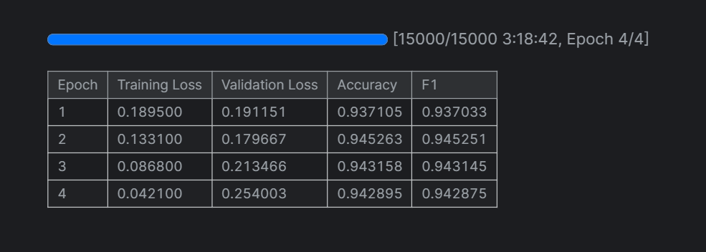
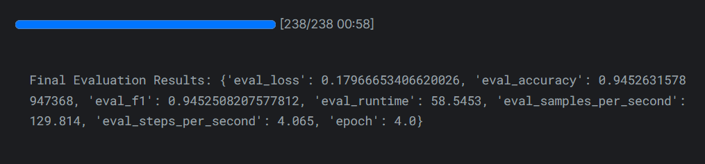
- Test Results: The final evaluation on the test set showed:

  - DistilBERT’s steady improvement in accuracy and F1 score, combined with its fast training, made it the best choice for our task.
- RoBERTa:
  - RoBERTa Training and Validation Results:
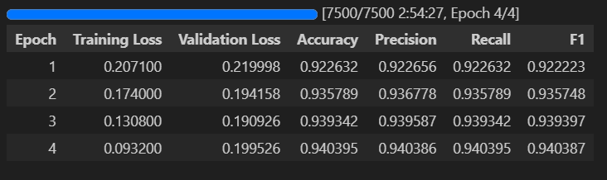
- Test Results: The final evaluation on the test set showed:
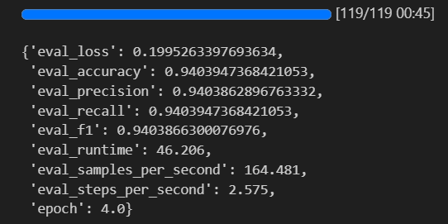
  - “RoBERTa scored slightly higher but took much longer to train, making it less practical.”
- ALBERT:
- ALBERT Training and Validation Results: 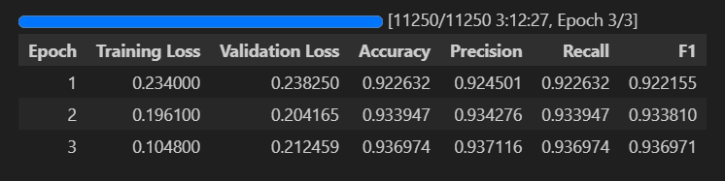
- Test Results: The final evaluation on the test set showed:
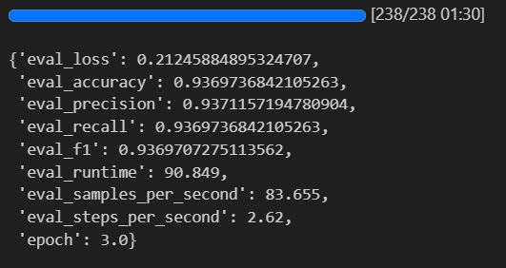
  - “ALBERT was faster but had lower accuracy compared to DistilBERT.”

- GPT 2 :
- GPT2 Training and Validation Results:
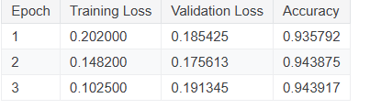

- Visualization:
Training Loss and Validation Accuracy Curves:
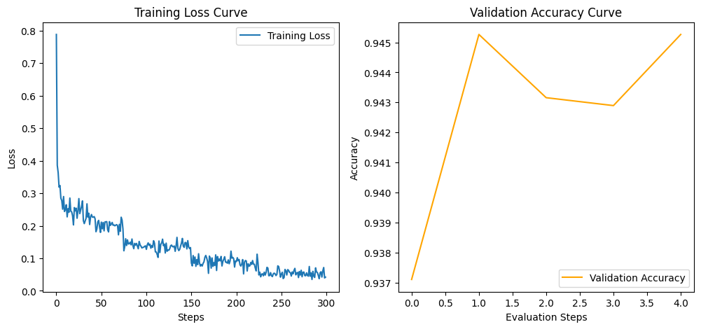
- Challenges We Faced
- The data had some issues, like extra \ symbols in the text, which could confuse the model. We fixed this by writing a cleaning function to remove those symbols and other noise like punctuation.
- Since we were working on a platform with limited resources, we had to choose a model that wouldn’t take too long to train or use too much memory, which is why DistilBERT was a good fit.
- We also had to make sure the model didn’t overfit (memorize the training data too much), so we used early stopping and a small penalty (weight decay) to keep it balanced.

